

Partnership Sunday

Trinity Sunday 2020



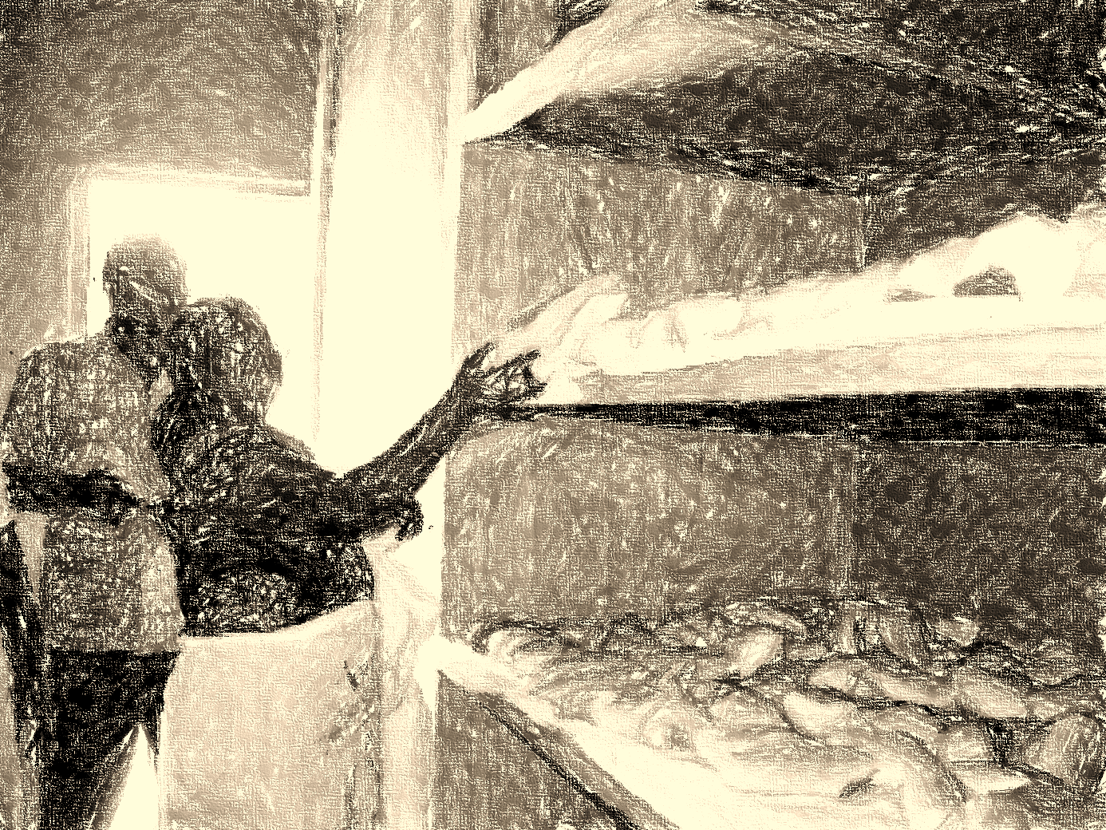

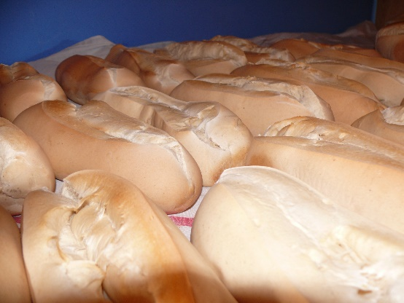

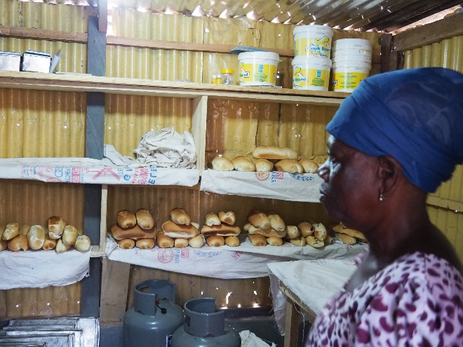

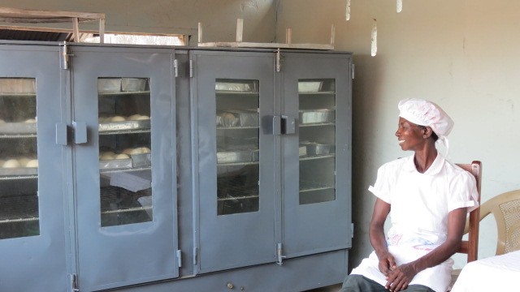

If the bread we share...

**Editor:**

Norddeutsche Mission / Bremen Mission

Berckstraße 27

D-28359 Bremen

Phone: 0421/ 467 70 38

info@norddeutschemission.de

www.norddeutschemission.de

Account: IBAN EN45 2905 0101 0001 0727 27

BIC: SBREDE22

Sparkasse in Bremen

Editorial office and responsible in the sense of the press service: Heike Jakubeit

This service was prepared by a small circle of friends of the Bremen Mission in the Evangelical Lutheran Church in Oldenburg: Rev. Brigitte Gläser, Dr. Detlev Lauhöfer, Rev. Rüdiger Möllenberg, Rev. Birgit Pflugrad.

We would like to thank all those who have contributed to this collection of material for the service: Rt. Rev. Dr. Seth Senyo Agidi (Evangelical Presbyterian Church, Ghana),   
Rev. Nyuieme Ama Adiepena (Evangelical Presbyterian Church, Ghana),   
Anneke Bargheer (Evangelical Ref. Church), Rev. Anne-Kathrin Schneider-Sema (Protestant Church of Bremen).

You can download the **worship service regulations** as a PDF or Word file from our website under **Service/Download/Partnership Services.**

Table of contents   
  
Introduction 4

Service order 5

Service schedule 6

Sermon impulses

Bread of life 15

Sermon draft Mt 13,33 17

The old man and the laid table 19

Being leaven 20

Creeds

Confession of the EEPT 21

The Seoul Confession 22

The Belhar Confession 23

Songs

If we share our bread, we share our lives 25

Bread and Roses (Lyrics) 26

# Introduction

For those who had undertaken a project trip as part of the General Assembly meeting, which took place last year in Ho, Ghana, the visit to a bakery was still a particular memory.

When telling about it, the smell of the freshly baked bread seemed to float through the room and its taste was on the tongue. Someone from the preparation team had a loaf of bread to share. It was still pre-Corona time.

In this bakery in Ghana, three women experience how they can benefit from economic independence. However - according to the shared and general experience - economic independence is no guarantee for a non-violent life, power-free circumstances and relationships. Bread alone is not enough. And money alone is useless.

Beside these experiences there is the proclamation of the church, which wants to make Jesus palatable to the people as "bread of life". This is how Jesus introduced himself to the people. He wants to satisfy the hunger for life by at the same time always pointing to those who, under the conditions of this world, are still hungry for bread and justice.

When does a foodstuff become a foodstuff? How does bread become the "bread of life"?

The worship service should invite to contemplate at the same time the abundance of life and its scarcity. The abundance that satisfies the hunger for life, because God's attention, his love, belongs to us unconditionally and the view to our neighbor's situations of scarcity that results from this. For where God's love dwells, charity is also at home.

If bread is the "bread of life", then we have to face the question of emotional, social and economic participation again and again. It can happen that we have to unlearn old things and give up traditional values, which are against this claim of participation. In its release, new and different ways of dealing with one another without power and violence can be found. The meaning of it some of us made clear through their attitude during the Corona period through their personal commitment to others.

The worship service drafts, which are made available year after year by the Bremen Mission for the celebration of the Partnership Sunday, are "patchwork". Therefore, a very free handling of them is recommended. Everyone may use whatever he or she likes.

Heike Jakubeit

**Service order**

**Music**

**Voting and greeting**

**Song**

**Psalm**

**Collection Prayer**

**Song**

**Reading: 1st Kings 19:1-8**

**Confession of Faith**

**Song**

**Sermon: Matthew 13:33**

**Song**

**Announcements and offering**

**Intercessory prayer**

**Our Father**

**Song**

**Blessing**

**Music**

**Suggested songs**

If the bread we share; If we share our bread, we share our lives (see Appendix); What shall we drink (Bots); Let us break bread together; Bread and Roses

**Psalm selection**

Ps 23, Ps 32, Ps 34, Ps 132, Ps 145

**Confession of Faith**

Confession of the Eglise Evangélique Presbytérienne du Togo, the Belhar Confession, the Seoul Confession (all see appendix)

**Further suggestions for celebrating the sermon**

Celebrating the Lord's Supper or Agape meal, offering dance

# Service schedule

# Voting and greeting

We celebrate this partnership service in the name of God,

who is like father and mother to us,

- source and goal of our life,

in the name of his son, our brother and Lord Jesus Christ,

by which we become one

and in the name of the Holy Spirit,

who wants to strengthen us in soul, spirit and body. Amen.

Welcome to this service, which the congregations of the member churches of the Bremen Mission in Ghana, Togo and Germany celebrate in fraternal solidarity. All there where they are just now.

"If the bread we share..." - Is this actually a conditional sentence or is it not rather about the consequences of people sharing? Is it enough just to share bread, or does it not mean much more?

A difficult time lies behind us, which, in addition to all the suffering and horror, fear and worry, has also made us aware that in times of pandemic and state of emergency, this too is possible: That strangers care for each other and about each other and that suddenly helpful, alternative ideas of care arise.

How much more would this actually be the case in a community where people know each other?

# Song

# Psalm (depending on your choice)

# Collection Prayer

Lord our God,

to you we come, for you we hope.

You give us what we need:

Bread for the body and bread for the soul.

We need both every day:

Food and trust, eating and community, bread and love.

Let us be frank now,

that we hear your good word and feel your love -

and share it with each other.

That is what we ask you for through Jesus Christ, our Lord and brother, who lives and gives life with you and the Holy Spirit from eternity to eternity. Amen.

(Rev. Birgit Pflugrad)

# Reading: 1st Kings 19:1-8

# When King Ahab reigned around 850 B.C., nobody took the first commandment, which forbids the worship of many deities, very seriously. Through the king's marriage to the pagan Jezebel, a god called Baal therefore became very popular. Jezebel commands the reconstruction of dilapidated cult sites of Baal, which had almost fallen into oblivion.

The prophet Elijah takes decisive action against her and the idolatry. And he does not shy away from violence. With the help of allies, he succeeds in killing the so-called "Prophets of Baal" to put an end to the cult. Jezebel does not know anything about it until her husband tells her. 1 And Ahab told Jezebel all that Elijah had done and how he had slain all the prophets of Baal with the sword. 2 Then Jezebel sent a messenger unto Elijah, saying, So let the gods do to me, and more also, if I make not thy life as the life of one of them by tomorrow about this time. 3 And when he saw that, he arose and went for his life, and came to Beersheba in Judah, and left his servant there. 4 But he himself went a day’s journey into the wilderness, and came and sat down under a juniper tree and he requested for himself that he might die, and said, It is enough; now, O LORD, take away my life; for I am not better than my fathers. 5 And as he lay down and slept under a juniper tree, behold, then an angel touched him, and said unto him, Arise, and eat. 6 And he looked, and, behold, there was a cake baked on the coals and a cruse of water at his head. And he did eat and drink, and laid him down again. 7 And the angel of the Lord came again the second time, and touched him, and said, Arise and eat; because the journey is too great for thee. 8 And he arose, and did eat and drink, and went in the strength of that meal forty days and forty nights unto Horeb the mount of God.

(Luther 2017)

# Confession of Faith

"Arise and eat! Cause you got a long way to go!" Let yourself be strengthened for your path of life and faith, confess the power that is the origin and goal of our wanderings, be sure of yourself.

I believe in God the Father,  
 the Almighty,  
 the Creator of heaven and earth.   
And in Jesus Christ,  
 His only begotten Son, our Lord,   
conceived by the Holy Spirit,  
born of the Virgin Mary,  
suffered under Pontius Pilate,  
crucified, died and buried,  
descended into the kingdom of death,  
rose from the dead on the third day,  
ascended into heaven;  
 He sits at the right hand of God  
 the Almighty Father;  
 from thence He will come to  
 judge the living and the dead.   
I believe in the Holy Spirit,  
 the Holy Christian Church, the  
 communion of saints, the  
 forgiveness of sins, the  
 resurrection of the dead and  
 eternal life.

Amen

# Song

# Sermon - Matthew 13:33

The kingdom of heaven is like leaven, taken by a woman and mixed under three bushels of flour until it was completely leavened.

(Luther 2017)

**(Sermon impulses composed by Anneke Bargheer, Dieter Bökemeier, Rüdiger Möllenberg, and Anne-Kathrin Schneider-Sema can be found in the appendix)**

The grace and peace of God be with us all!

We thank God for the celebration of this Partnership Sunday in the name of Christ! May our good Lord strengthen us, so that we may walk our paths together with Him, especially when we are put at His service as partners.

Interestingly, one speaks of "bread" when food is meant. And "bread" is indeed a staple food in many countries, even if it is prepared differently and has a different form in each case.

Food puts an end to hunger and enables the body to perform its various functions: exercise, social activities and also its mental apparatus.

Bread, therefore, provides the body with nourishment. Bread also brings people together socially, because food is shared in community. The beauty of the laid table arises joy - and so bread ultimately also has a psychological effect.

When these three meanings come together, then a body is provided for holistically and can enjoy a truly worthwhile life.

And that is what everyone wants: a life that gives satisfaction, both spiritually and in terms of the body.

Jesus says of himself that he is the bread of life. He is the one who gives satisfaction to the world. A contentment that satisfies spiritual demands and what a body needs.

In the Gospel according to Luke, Jesus says in the fourth chapter of the fourth verse that a man cannot live on bread alone. This means that Jesus is fully aware that food alone does not satisfy human hunger. Because: people also need spiritual food to be satisfied with their lives.

I want to talk about how Jesus can give people what they need in all situations in life.

He supplied 5000 people who were hungry with only five loaves of bread. He gave new hope of life to the woman with the issue of blood who was pervaded by hopelessness. He made a blind man see so that he could feel joy in his heart again. To the mother who had lost her only son to death, Jesus brought the child back to life. Can you imagine the happiness she felt?

And to the adulteress who was to be stoned, he helped her to justice. The woman he met at the well, he encouraged to empower herself, which made her very fearless and enabled her to connect others with Christ.

Perhaps this is why the evangelist Matthew (Mt 15,21 -28) reports that the Syro-Phoenician woman is satisfied with even the smallest crumb under the table, which the dogs usually eat. This woman is firmly convinced that everything - even the smallest thing - that Jesus can give makes her life rich.

The talk of the "bread of life" points to the importance of food in the lives of people. When Jesus himself says of himself that he is the "bread of life", is he not even more important in the lives of people than food and drink alone?

It is He who can work into all aspects of human life in such a way that it can be left entirely to Him - in this world and in the world to come. Wherever there is life!

His message of love, hope, forgiveness and deliverance can permeate the whole world, just as the leaven permeates the flour in the parable reported by the evangelist Matthew. The Kingdom of Heaven is like unto leaven, which a woman took, and hid in three measures of meal, until the whole was leavened. (Matthew 13:33)

This calls us to present Jesus as the "bread of life" to all people in the world. For Jesus gives hope to the hopeless, brings joy to the desperate and justice to the oppressed.

Different living conditions require different answers in order that life is to be worth living. The church must express its concern in these different conditions for life.

Into which situations in life should the church speak?

Into solitude. Where people hunger for community. There are people who desperately need someone to talk to. Visiting neighbours who are lonely, sharing God's love with them or singing together with them can satisfy the hunger for community.

The church should also give a voice to people who have none in society. They suffer from the fact that their concerns are often not heard because of their position in society. Christians must give a voice to those who do not have one, so that their concerns are met.

Where infidelity and abuse are found in marital relationships, the church must remind couples that they have made entered a bond of marriage for the glory of God.

Even where people experience rejection because of their illness, the church must take their side. I am thinking especially of those who are HIV positive and AIDS patients. They are completely rejected by their families and friends, a society. Nobody cares about them because they have nothing to give back. Although Jesus calls us to love people who cannot give anything back.

Their traditions and culture can imprison people. Then life is no longer worth living. This is how women live in a male-dominated world. This also applies to the church. There women are less involved in decision-making processes, although many decisions affect them and the decisions taken (by men) are far from satisfactory. Here the church could bring about change. It speaks into the situation when women are involved in decision-making processes and when they are allowed to make decisions for themselves.

Jesus said, "I was hungry and you did not give me food." People are hungry for the Word of God, both spiritually and physically. For them, life is then meaningless if they cannot be helped, so that they learn to appreciate the wonderful sources of life that God has given them. How can the Church succeed in this, so that they too can taste the "bread of life"?

Jesus says that He came to give us life abundantly (John 10:10). This abundance concerns all areas of life. Whatever challenges may arise in our path: If we have Jesus as the "bread of life" and know about it, we will surely have a life worth living.

Our life journey through this world is not easy or comfortable. We absolutely need "bread of life", Jesus, so that we have strength for our ways. (1 Kings 19:8) As we go on, we can then say: Our souls are doing well!

May our good Lord help us. Amen.

(Nyuieme Ama Adiepena)

# Song

# Announcements and offering

If the bread we share...

For holistic hospital pastoral care

Abra Ako is a 52 year old widow and seriously ill. As a trained nurse and deaconess, she looks after people suffering from AIDS or tuberculosis in the "CHU Tokoin" hospital in Lomé, Togo, to the limits of her strength. "Three-quarters of these sick people are abandoned by their families," she says.

The health system in Togo functions in such a way that patients in hospital only receive treatment. The respective families have to provide medication, food and clothing

"I am incredibly happy and grateful to receive donations through the Bremen Mission," says Abra Ako.

With her modest budget, Abra Ako is now able to provide about 50 patients a month with the absolute essentials in addition to her pastoral work. "There is a lack of food, soap, clothing and blankets."

Many more people would need her help. "Most people only have what they wear on their bodies," she says.

Maybe you want to support the work of Abra Ako. So that people who are stigmatized because of their illnesses are given the most necessary things and they can have confidence in life again. So that the soul can be healed.

On behalf of Abra Ako and all those in Togo who are particularly hard hit by the fate of being abandoned in case of illness, the Bremen Mission says "Thank you" for your support.

# Intercessory prayer 1

"I am the bread of life. Whoever comes to me will never be hungry, and whoever believes in me will never be thirsty," says Jesus Christ. (John 6:35-51)

Merciful Father, you have heard the prayers of your people in the desert and have fed them with bread from heaven despite their sin. Hear us today with mercy and feed us with the bread of life from heaven. Have mercy on those whose lives have been destroyed by violence and crime and on our brothers and sisters in prison. Feed them with hope and a new life in Christ.

Today we humbly pray for all the women who work in a bakery project and who, despite the violent structures in which they live, continue to provide for family and children, grow and prepare food, carry water, earn a living and provide support to others.

Jesus - bread of life, you nourish us through word and sacrament.

The bread we share is a reminder of your presence with us. Strengthen us for service like Elijah, even if the journey is long and we are hungry and thirsty.

Jesus - bread of life, strengthen us.

We pray for orphans, widows and pregnant women who work hard for their daily bread to feed their unborn children and provide for the family.

We pray for single parents who are without bread to survive.

We pray for the war-torn areas where bread for life is scarce.

We pray for the homeless and destitute who can hardly afford their daily bread.

We pray for areas suffering from drought and famine, and also for areas attacked by locusts that destroy their crops and deny people their daily bread.

We pray for refugees and immigrants who are searching for daily bread.

O God, our help in the past and our hope for the times to come, you have promised justice for the oppressed, bread for the hungry, freedom for the captives and relief for all who are burdened. In Christ, you offer life to all.

Jesus - bread of life, you nourish us through word and sacrament, so that we can nourish others. Blessed be thy name.

May our Lord Jesus Christ, the Bread of Life, enable us to grasp what is in Him, all the food we need to grow spiritually - true bread that satisfies hunger forever - so that we may proclaim His peace and love in our lives now and forever.

In the name of God the Father, the Son and the Holy Spirit. Amen.

(Dr. Seth Senyo Agidi)

# Intercessory prayer 2

**You,** God of peace and justice, you accept us as your creatures, as your children. You meet us with love and mercy. We have heard your word and call out to you: *Hear us, God*

**Gracious God**

keep us from becoming loveless where the seed of your word does not sprout.

Send your spiritual power that we may treat each other, our fellow creatures, yes, your entire creation, with respect and love and let them share in the richness of your gifts, so that no one may hunger in body and soul.

We cry unto thee: *hear us, God*

**God,** we see how violence, war, fear and envy threaten and even destroy the beauty of your creatures and of creation.

We ask for the help of your spirit power:

That we break the spiral of violence,

that communities, congregations and the many people who seek peace and participation are strengthened and heard

We cry unto thee: *hear us, God*

**Merciful God**, we ask You for the victims of the worldwide epidemic, we ask You for all people who are coming up against limits:

for the sick, for the lonely,

for the elderly who are burdened with life,

for those who flee, for those who are denied the good life and for those who die:

Give them your support and dear people who are with them. Let them and us feel again and again: All our lives are secure in your eternal faithfulness.

We cry unto thee: *hear us, God*

**God, we thank** you for the lifetime you have given to each one of us. Help us to understand that the limits set for us make our lives precious and beautiful.

And forgive us where we have become tired and careless in our discipleship. Send your Holy Spirit so that we may find new strength and confidence in faith.

Lord God, let us pray together:

(Rev. Brigitte Gläser)

**Our Father**

**Song**

# Blessing

The Lord bless you.

He fills your feet with dance and your arms with strength.

He fills your heart with tenderness and your eyes with laughter.

He fills your ears with music and your nose with fragrances.

He fills your mouth with rejoicing and your heart with joy.

He gives you again and again the grace of the desert:

Silence, fresh water and new hope.

He gives us again and again the strength to give hope a face.

The Lord bless you.

Amen

**Music**

# Sermon impulses

**Bread of life**

To illustrate this, an approximation of the properties of bread is possible. Bread can be brought along. It can be touched and smelled. It can be tasted. And bread can also be heard, e.g. the sound when bread is cut or broken.

Breaking bread

* The term breaking implies a connection to destroying: Break a leg, break a connection, break a vase, break a contact, break trust, break a promise, break resistance... And often the sounds associated with breaking are horrible.
* When bread is broken, it is "destroyed". The whole loaf is cut into pieces. The bread is broken, but is it *broken* by this? Does breaking “destroy” the bread? Or can its meaning only develop through the breaking, through the "destruction" of the loaf? What associations does the sound of breaking bread evoke?

Sharing bread

* Only the bread that is broken can be shared. It cannot belong to just one person, but to many. It cannot satisfy only one person when it is shared, but many.
* Sharing bread connects with each other. Sharing bread creates community.
* Sharing bread makes us participants, and we can make others participants.
* Through sharing, we become recipients of bread, of encouragement, of recognition, of hope, of empowerment...

When we break bread together and share it with one another, the life of the living body of Christ is passed on. The bread that is hoarded and locked away in the pantry quickly becomes rotten and bad.

It cannot become life-giving bread. Out of selfishness, injustice grows. Only when the bread is shared, it can become the source of justice and make the fellowship of the Body of Christ grow.

The bread of life reflects the paradox of the communion of Christ. We break the bread into many pieces, but we do not destroy it in the process. By "destroying" and breaking up the original, something new is created that creates life and hope. It is through breaking that bread can connect us to one another. The breaking of bread gives solidarity and lets community and partnership grow. Only by breaking the bread, we can share it and let all who need the bread of life share in it.

(Anneke Bargheer)







**Sermon draft on Mt 13,33: About leaven**

*Small cause - powerful effect:*

During my studies, I baked bread myself for a while, without a baking machine and with real sourdough. Once made or got as a gift from someone else, you could reuse it very often. You kept a little of the finished bread dough, added some flour and put it in the fridge. This was the basis for the sourdough for the next bread. Later we stopped baking bread ourselves; it was a lot of work. However, the taste was unbeatable.

The "invention" of leaven was an important step in human nutrition. It makes bread edible and digestible. Rye is even made bakeable by the lactic acid bacteria and yeast fungi in the sourdough. In many cultures, soured bread as a staple food has become an indispensable part of the diet.

*Small cause - powerful effect:*

Sourdough plays a role in the Bible repeatedly. In the First Testament in the 2nd book of Moses, the children of Israel had no more time to prepare leaven for bread during their hasty flight from Egypt (Ex 12). Therefore, they took only hard, unleavened bread as provisions. This is what the matzo, a thin sheet of bread, reminiscent of thin crispbread and eaten at the Jewish Passover, reminds us of.

Jesus uses the image of leaven twice - and in doing so, he describes both times a great dynamic with which something happens. For example in the negative sense: He compares the negative energy of his opponents ("Sadducees and Pharisees") with the power of the leaven: It will affect the whole dough, that is, it will acidify it (Mt 16:6).

However, Jesus also uses the image in a positive sense for the dynamics of the Kingdom of God. "The kingdom of heaven is like leaven that a woman took and mixed under three bushels of flour until it was completely leavened." Compared to an unjust world, it is now as small and inconspicuous as a bit of leaven in a large bowl of flour. However, it will unfold its beneficial effect and inevitably cover the whole dough. It only takes time and patience.

*Small cause - powerful effect:*

February 2020: A small visiting group from Lippe is on its way to the E.P. Church, Ghana, especially in the north of the country. Yes, also in Ghana you can get leavened bread or bread made with yeast. What is also available is for example "Banku", a dough ball made of corn flour and e.g. cassava, which is fermented, i.e. soured and eaten with a spicy sauce - a typical Ghanaian dish.

However, the group also experiences souring dynamics in other ways on the trip to the north, which has arisen from partnership.

About 38 years ago, a group of mostly young people from the Lippe Regional Church visited the partner church in Ghana and came to the small village of Alavanyo where the establishment of an artisan school of the E. P. Church had just been started. The short meeting triggered a dynamic on both sides: After their return, the Lippe people founded a one-world shop in Detmold and named it after the place of the school: Alavanyo. This year, the shop is 38 years old, has a considerable turnover with fair trade goods and generates a surplus every year. A part of it is always given as a donation to the growing school in Alavanyo/Ghana.

Also there many people are active (the leaven works). Through their commitment, the Evangelical Presbyterian Technical Vocational Institute has grown considerably. Today the school has over 650 students who are trained in various professions. This is dynamic of the Kingdom of God. It only needed time and patience.

*Small cause - powerful effect:*

It is important to hold on to such images of hope in a time of depressing news. The murders in Hanau, the climate change that is obviously already far advanced, nationalist ruthlessness that is spreading, pandemic.

So it is good to know that God has prepared the leaven and that it is effective, despite many negative headlines. The work of the Bremen Mission is such a hopeful effect.

(Dieter Bökemeier)

# The old man and the laid table on the run

The elderly man approached me after a prayer for peace. Up to now, he was always very reserved, but this time he addressed me directly.

"May I tell you about the 23rd Psalm we just prayed?" I did not expect anything interesting, but I agreed. After all, I did not want to be rude.

"It was in the last days of the war," he began. “I was just a little boy and on the run with my family. It had been a long time since we had been given anything decent to eat. We heard the Stalin organs not too far away when we came to a lonely house with lights on.

No one answered our knock. So we just walked in. Apparently, officers had been quartered here, running from the Russians head over heels.

They had left behind a richly set table. The food was even still warm, and a freshly baked bread exuded its scent throughout the room. Speechless we sat down and my father prayed the 23rd Psalm. ...you have prepared a table for me in the presence of my enemies...

My father broke our bread and we ate our fill. It was delicious, you know, and I just had to tell you this experience. I can still smell the bread.”

Without waiting for a reaction, the man said goodbye friendly.

(Rüdiger Möllenberg)

**Being leaven**

I was once a grain of wheat. There I stood in a field with my brothers and sisters. With the power of the earth God's blessing flowed through me, with every ray of sunshine I felt His Spirit on me. It was like in a dream. I felt free and secure at the same time. Then the wheat was harvested. It took some time, in the end I became a grain of flour. Together with others, I lay in a dark sack. Waiting for something to be made of me.

It is dark and stuffy in that bag. There can be no talk of freedom, not even of security. However, I carry the longing for it deep in my heart. The longing for support, for security. Also the longing for belonging to something big again. After all, I was never alone at the ear of the corn. But the greatest of all is the longing to feel God's blessing again.

One day the bag is opened. One hand reaches in, takes out flour with full hands. Once, twice, three times. I too end up in a bowl. A woman pours leaven into it and starts kneading us. Then the woman leaves us alone. She dusts some more flour on us, and then covers us with a cloth. It is now warm and dark in the bowl. "Resting", I think.

But after a little while, something happens again. I can feel myself being pulled. Or is it pressed? It is getting warmer and warmer around me, I can feel it clearly. And there is a force at work that I can hardly describe. A force that is pulling us apart; pushing us higher and higher. I can feel us getting bigger and bigger, I can feel the cohesion between us getting stronger and stronger. No one is alone here anymore, we belong together. Warmth and light are spreading around me. It feels like when I was in the field: it is God's power that flows through me. It lies blessing on me. It is a wonderful feeling ... and it has become reality.

(Anne-Kathrin Schneider-Sema)

**Creeds**

**Confession of the Eglise Evangélique Presbytérienne du Togo**

We believe that God has a purpose for the world in general and for humanity in particular.

We believe that man's sin is an obstacle to this divine purpose and has made it necessary for a Saviour to come. This Saviour, the only Saviour, is Jesus Christ, our Lord.

We believe that in Jesus Christ the plan of God has been fulfilled and we look forward to its full unfolding.

We proclaim that the Church is the community of all those who, under the action of the Holy Spirit, glorify God in Jesus Christ. In this way, we become God's witnesses and collaborators in the world.

This is what gives us pleasure.

Amen.

# 

**The Seoul Confession**

I believe in God, who is love and who has given the earth to all people.

I do not believe in the right of the strongest, in the strength of arms, in the power of oppression.

I believe in Jesus Christ, who came to heal us and who delivers us from all deadly dependencies.

I do not believe that wars are inevitable, that peace is unattainable.

I do not believe that suffering must be in vain, that death is the end, that God has wanted the destruction of the earth.

I believe that God wants an order for the world based on justice and love, and that all men and women are equal.

I believe in God's promise of a new heaven and a new earth where justice and peace kiss.

I believe in the beauty of simplicity, in love with open hands, in peace on earth.

Amen.

(World Assembly of Christians in Seoul 1990 "Confession of Peace and Justice")

# 

**The Belhar Confession**

We believe in the one God, Father, Son and Holy Spirit, who gathers, protects and sustains the church from the beginning of the world to the end.

The Church is One, the Church is holy, the Church is universal. It is the community of the children of God, called from the whole human race.

We believe that Christ's work of reconciliation brings a uniting Church into being, because the unity of the Church is a gift from God and a goal to which we must strive.

The unity of the church must be made visible so that those around us can see how separation and hatred have been overcome in Christ.

We believe that true faith in Jesus Christ is the only requirement for membership in this Christian Church.

Thus, we praise God that neither skin colour, class, gender nor culture determine who belongs to this Church.

We believe that God has entrusted to the Church the message of reconciliation, that we are called to be peacemakers: the salt of the earth and the light of the world.

We celebrate God's victory through the cross of Christ over all forces of division and bitterness. This makes us a community of hope, working for peace and unity.

We believe that God wants to bring true justice and lasting peace on earth. We believe that God is in a special way a God of the needy, the poor and the disenfranchised.

God makes justice for the oppressed and gives bread to the hungry; God frees the captives and makes the blind see. God protects strangers, orphans and widows and thwart the plans of the wicked.

We believe that the Church as God's property must stand where God himself stands: against injustice and on the side of the disenfranchised.

We oppose any policy that creates injustice: we bear witness to all powerful people who pursue their own interests and hurt others. We stand with those who suffer - and share our lives with them.

We are called to confess and do all this in obedience to Jesus Christ, our only Lord, even when authorities and laws are against it, even when punishment and suffering are involved.

The Lord is Jesus! Him we follow! To the one God, Father, Son and Holy Spirit, be glory and honour forever and ever!

Amen.

(Liturgical version)

# 

**Songs**

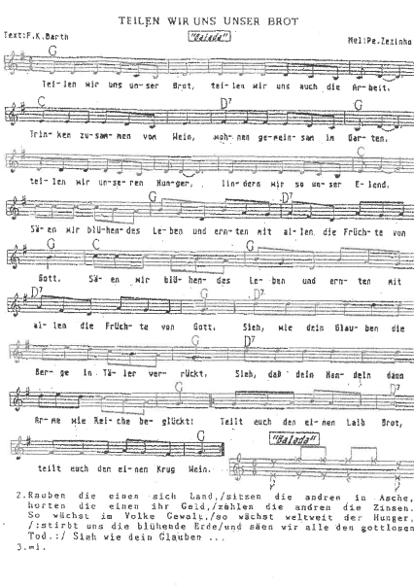**Let us share our bread**

(For sheet music see https://www.luteranos.com.br/textos/por-um-pedaco-de-pao; download: Partitura Cantate Domino 3 vozes)

**Bread and Roses Song**

**Bread and Roses**

As we go marching, marching, in the beauty of the day,   
A million darkened kitchens, a thousand mill lofts grey,   
Are touched with all the radiance that a sudden sun discloses,   
For the people hear us singing: Bread and Roses! Bread and Roses!  
  
As we go marching, marching, we battle too for men,   
For they are women's children, and we mother them again.  
Our lives shall not be sweated from birth until life closes;   
Hearts starve as well as bodies; give us bread, but give us roses.  
  
As we go marching, marching, unnumbered women dead  
Go crying through our singing their ancient call for bread.  
Small art and love and beauty their drudging spirits knew.  
Yes, it is bread we fight for, but we fight for roses too.  
  
As we go marching, marching, we bring the greater days,   
The rising of the women means the rising of the race.  
No more the drudge and idler, ten that toil where one reposes,   
But a sharing of life's glories: Bread and roses, bread and roses.  
  
Our lives shall not be sweated from birth until life closes;   
hearts starve as well as bodies; bread and roses, bread and roses.  
  
(James Oppenheim)

MUSIC: Mimi Farina

(For sheet music see https://www.8notes.com/scores/3696.asp)

